Design Report — End-to-End Analytics Engineering Pipeline
Sharon Nasimuyu
Table of Contents

Scope: Near-real-time analytics pipeline from a public REST API through an OLTP database, CDC streaming, ClickHouse, and layered dbt transformations to analytics- and ML-ready datasets.
Data source: World Bank Indicators REST API — https://api.worldbank.org/v2/ (public, no authentication). Primary endpoints: /v2/country (country dimension), /v2/indicator (indicator dimension), and /v2/country/{code}/indicator/{code}?format=json&per_page=… (annual observation values per country/indicator). The design pattern is source-agnostic; the World Bank dataset — indicator values per country per year — is used to make the schema concrete because its time-series shape best demonstrates ClickHouse partitioning, ordering, and materialized-view choices.

1. Overview
The pipeline ingests operational data from the World Bank REST API into PostgreSQL (OLTP), captures every row-level change with Debezium, streams those changes through Kafka into ClickHouse (OLAP), and refines the raw change stream into staging (clean, current-state) and mart (analytics- and ML-ready) layers with dbt. Airflow orchestrates the batch stages; CDC runs continuously. The full stack is containerized with Docker Compose and validated on every change by a GitHub Actions CI/CD pipeline. Prometheus, Grafana, and n8n provide observability and alerting.
Design priorities, in order: correctness (idempotent, deduplicated, CDC-aware loads), near-real-time freshness, query performance on ClickHouse, and operability (everything monitored, one-command startup, tested on every commit).

2. Architecture Diagram
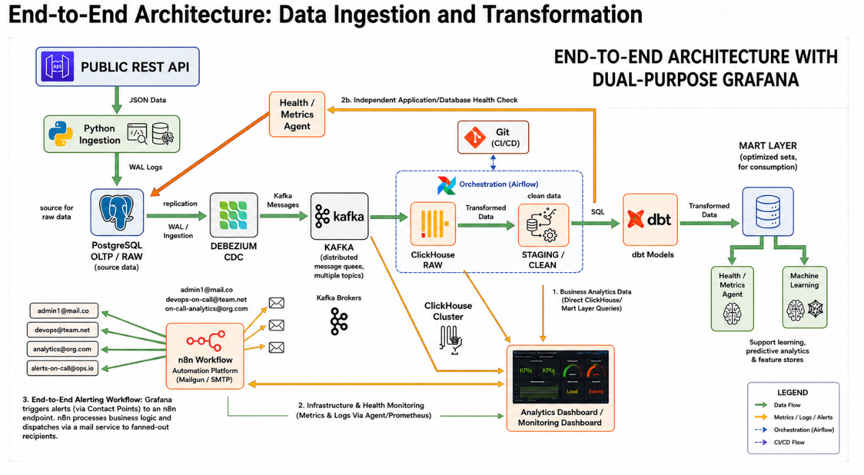
End-to-end architecture
Component responsibilities
Layer | Technology | Responsibility
Ingestion | Python (requests/httpx) | Pull REST API, paginate, validate, idempotent upsert into OLTP
OLTP | PostgreSQL | Source of truth; logical replication enabled (wal_level=logical)
CDC | Debezium (Kafka Connect) | Capture INSERT/UPDATE/DELETE from WAL
Streaming | Apache Kafka | Durable, decoupled transport; one topic per source table
OLAP | ClickHouse | Raw CDC landing + analytical storage
Transformation | dbt | Raw → staging → mart, with tests
Orchestration | Airflow | Schedule/monitor ingestion + dbt; retries, backfills
Containerization | Docker Compose | One-command startup of the whole stack
CI/CD | GitHub Actions | Lint, unit tests, dbt build/test on every push/PR
Observability | Prometheus + Grafana + n8n | Metrics, dashboards, alert fan-out
Data quality | dbt tests + Great Expectations | Validation gates at each stage

3. Data Flow Explanation
1. REST API → PostgreSQL. A Python ingestion service calls the World Bank API — first the reference endpoints (/v2/country, /v2/indicator) to populate dimensions, then /v2/country/{code}/indicator/{code} for observation values. It handles the API’s page-based pagination (the response envelope carries page, pages, per_page, total), performs basic response/schema validation, and upserts records into PostgreSQL. Ingestion is idempotent (upsert on the natural key country_code + indicator_code + obs_year), so reruns never create duplicates. PostgreSQL is the OLTP source of truth, with primary keys and timestamps supporting incremental ingestion.
2. PostgreSQL → Debezium → Kafka. With wal_level=logical, Debezium reads the write-ahead log and emits INSERT/UPDATE/DELETE events rather than polling. Events are published to Kafka topics (one per table). Kafka provides a durable, replayable, decoupled buffer between OLTP and downstream consumers, enabling near-real-time propagation without heavy database polling. This matters for World Bank data because indicator values are revised historically — an update to a prior year’s figure flows through as a CDC UPDATE rather than requiring a full reload.
3. Kafka → ClickHouse RAW. ClickHouse consumes the CDC topics (via the ClickHouse Kafka table engine feeding a materialized view, or the Kafka Connect ClickHouse sink). The raw layer stores the full CDC payload — the changed row plus operation metadata (op, ts_ms, source LSN) — giving an auditable, replayable record of every source change.
4. RAW → Staging. dbt flattens the nested CDC envelope, standardizes names and types, normalizes timestamps, applies CDC semantics (collapse to the latest version per key, honor deletes), removes duplicates, and runs basic data-quality checks. Staging is a clean representation of current source state, decoupling ingestion mechanics from analytical modeling.
5. Staging → Mart. dbt applies business logic — derived metrics (year-over-year growth, CAGR), regional/income-group aggregations, dimensional joins to country and indicator attributes, feature engineering, and standardized definitions — producing analytics-ready mart tables optimized for ClickHouse. Marts feed both BI/analytics and ML/feature consumption.
6. Orchestration. Airflow coordinates ingestion → staging → mart with scheduling, dependency management, retries, failure handling, and execution visibility. CDC runs continuously; batch ingestion and dbt runs are scheduled (e.g., daily, since World Bank data updates infrequently) and gated by data-quality tests.
7. Data quality (throughout). Validation is applied at every hop — API response validation, schema/type checks, PK uniqueness, null checks, record-count and reconciliation checks, referential integrity (every observation references a known country and indicator), freshness, and CDC-lag monitoring — so invalid data cannot silently propagate downstream.

4. Data Model / Schema Documentation

4.1 Source → OLTP (PostgreSQL)
The API exposes two reference collections (countries, indicators) and one observation series (indicator value per country per year). In OLTP this is modeled as two dimensions and one fact.
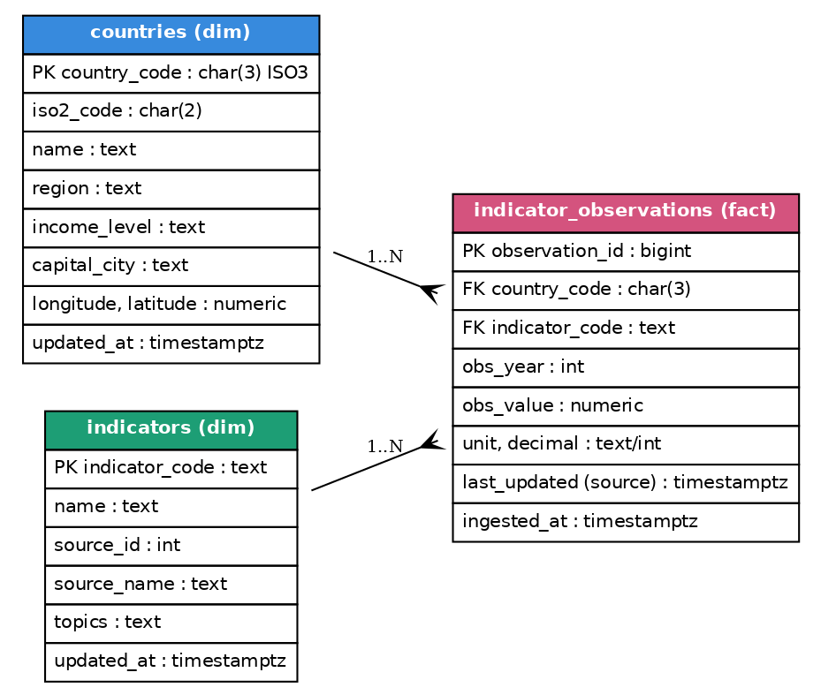
OLTP entity-relationship diagram

4.2 Staging & Mart (ClickHouse) ERD
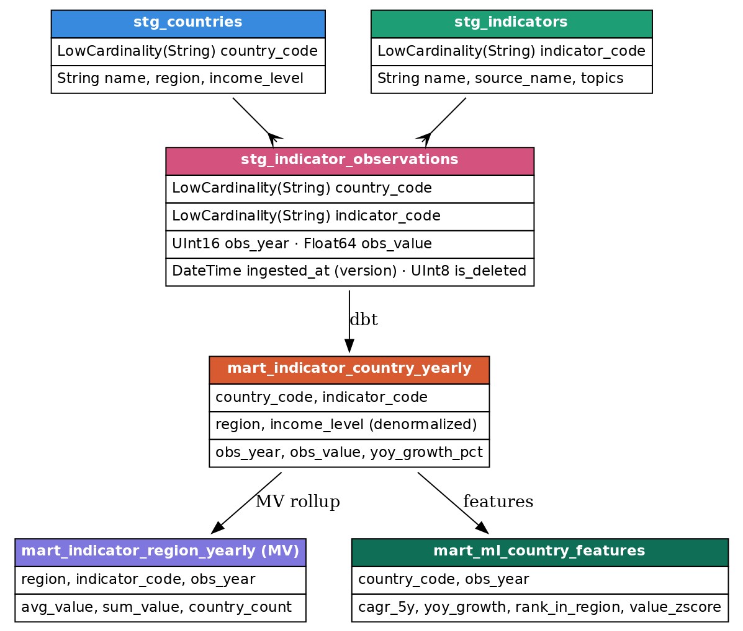
Staging and mart entity-relationship diagram

4.3 ClickHouse-specific design choices (rationale)
RAW landing table — capture everything, deduplicate later.
CREATE TABLE raw.indicator_observations_cdc
(
country_code String,
indicator_code String,
payload String, -- full JSON envelope
op LowCardinality(String), -- c/u/d/r
source_ts_ms UInt64,
ingested_at DateTime DEFAULT now()
)
ENGINE = MergeTree
PARTITION BY toYYYYMM(ingested_at)
ORDER BY (indicator_code, country_code, source_ts_ms);
Engine: plain MergeTree — the raw layer is an immutable, append-only audit log; we never mutate it, only read and transform forward.
STAGING table — collapse CDC to current state.
CREATE TABLE staging.stg_indicator_observations
(
country_code LowCardinality(String),
indicator_code LowCardinality(String),
obs_year UInt16 CODEC(DoubleDelta, ZSTD(1)),
obs_value Float64 CODEC(ZSTD(1)),
ingested_at DateTime, -- version
is_deleted UInt8
)
ENGINE = ReplacingMergeTree(ingested_at)
PARTITION BY intDiv(obs_year, 10) * 10 -- decade
ORDER BY (indicator_code, country_code, obs_year);
- Table engine — ReplacingMergeTree(ingested_at): the World Bank revises historical figures, so CDC produces multiple versions of the same (indicator, country, year). ReplacingMergeTree collapses rows sharing the ORDER BY key, keeping the row with the highest version column (ingested_at). This yields an efficient “latest known value” without manual dedup logic; reads use FINAL or a dedup pattern to guarantee the latest version. The is_deleted tombstone lets deletes be filtered downstream.
- Partitioning key — intDiv(obs_year,10)*10 (decade): the data is annual and spans ~1960 to present (65 years). Partitioning by decade keeps the partition count in single digits — avoiding the ClickHouse anti-pattern of many tiny partitions — while still enabling partition pruning on year-range queries and cheap retention via DROP PARTITION. (Monthly partitioning, appropriate for high-frequency sources, would be wasteful here.)
- Ordering / sorting key — (indicator_code, country_code, obs_year): matches the dominant query patterns (“this indicator across countries” and “this country/indicator over time”). ClickHouse’s sparse primary index skips granules efficiently, and physically co-locating each indicator’s series maximizes compression and range-scan speed. For a ReplacingMergeTree, the ORDER BY is the dedup key, so this also defines row identity: one indicator, one country, one year.
- Column codecs: DoubleDelta on the monotonic obs_year, wrapped in ZSTD, plus ZSTD on obs_value, shrink the time-series columns significantly. LowCardinality(String) for country_code/indicator_code cuts storage and speeds grouping/filtering (there are only ~200 countries and a bounded indicator set).
MART — pre-aggregate at insert time with a materialized view.
CREATE TABLE mart.indicator_region_yearly
(
region LowCardinality(String),
indicator_code LowCardinality(String),
obs_year UInt16,
avg_value AggregateFunction(avg, Float64),
sum_value AggregateFunction(sum, Float64),
country_count AggregateFunction(uniq, String)
)
ENGINE = AggregatingMergeTree
PARTITION BY intDiv(obs_year, 10) * 10
ORDER BY (region, indicator_code, obs_year);
CREATE MATERIALIZED VIEW mart.indicator_region_yearly_mv
TO mart.indicator_region_yearly AS
SELECT
c.region AS region,
o.indicator_code AS indicator_code,
o.obs_year AS obs_year,
avgState(o.obs_value) AS avg_value,
sumState(o.obs_value) AS sum_value,
uniqState(o.country_code) AS country_count
FROM staging.stg_indicator_observations AS o
INNER JOIN staging.stg_countries AS c USING (country_code)
GROUP BY region, indicator_code, obs_year;
- Materialized views: regional/income-group rollups are computed incrementally at insert time by an AggregatingMergeTree-backed MV, so dashboards read tiny pre-aggregated tables instead of scanning the full observation history. Queries finalize aggregate states with the -Merge combinators (or FINAL).
- Why not compute on read: aggregating the full fact per dashboard load is wasteful at scale; MVs shift the cost to write time (once) and keep reads O(regions × years) rather than O(observations).
- Projections (optional): for an alternate access path (e.g. “top countries by an indicator in year Y”), a projection provides a second physical ordering without a second table.
Analytics-ready fact. mart.indicator_country_yearly (a dbt model, MergeTree ordered by (indicator_code, country_code, obs_year)) denormalizes country attributes (region, income level) onto the fact and adds derived metrics such as year-over-year growth — the primary table for BI queries.
ML-ready table. mart.ml_country_features (a dbt incremental model, MergeTree ordered by (country_code, obs_year)) materializes point-in-time features (CAGR, YoY growth, rank within region, value z-score) with no leakage, ready for a feature store or direct training pulls.

5. Observability Design
Observability covers data health (is the data correct, fresh, complete?) and platform health (are the services up and performant?). Metrics flow Prometheus → Grafana (dashboards + alert rules) → n8n (routing/business logic) → email fan-out to on-call inboxes.

What is monitored
Category | Signals | Source / exporter
Pipeline health | Airflow DAG/task success/failure, task duration, retries, SLA misses | Airflow StatsD → statsd_exporter; dbt run results
Data freshness | now() − max(ingested_at) per table; dbt source freshness | Custom ClickHouse exporter / Pushgateway
CDC lag | Debezium MilliSecondsBehindSource, Kafka Connect task state; Kafka consumer-group lag; Postgres replication-slot lag | Kafka Connect JMX exporter; kafka_exporter / Burrow; postgres_exporter
Throughput / volume | Rows ingested, Kafka messages/sec per topic, rows written to ClickHouse | Ingestion app metrics; Kafka JMX; ClickHouse system.*
Resource usage | CPU, memory, disk, IO per container/host; ClickHouse merges, parts count, memory | node_exporter, cAdvisor, ClickHouse exporter
Data quality | dbt test pass/fail, Great Expectations checkpoint results, reconciliation counts | dbt artifacts, GE → Pushgateway
Service up/down | Liveness of Postgres, Kafka, Debezium, ClickHouse, Airflow, dbt | Prometheus up, blackbox probes

Alerting examples (Grafana → n8n → email)
- CDC lag MilliSecondsBehindSource > 60s for 5m → warn; > 5m → page on-call.
- Freshness no new rows in stg_indicator_observations after a scheduled ingestion window → alert analytics + on-call.
- Pipeline any Airflow task failed or dbt test error → alert with DAG/model context.
- Resource ClickHouse parts_to_throw_insert approaching limit, or disk > 85% → alert platform.
n8n applies routing/de-duplication/formatting and dispatches via Mailgun/SMTP so the right team gets a clean, contextual email rather than raw firing alerts.

Why these tools
- Prometheus — pull-based scraping, a mature exporter ecosystem for every component here (Postgres, Kafka, ClickHouse, node, cAdvisor, Airflow via StatsD), PromQL for flexible SLO queries, and cheap to run in Compose.
- Grafana — first-class Prometheus support, reusable dashboards, and built-in alerting with contact points → natural webhook hand-off to n8n.
- n8n — decouples alert generation from notification logic: business rules, throttling, and multi-channel fan-out live in one automation layer instead of being hard-coded per tool.
- dbt tests + Great Expectations — dbt tests gate the transformation graph (not-null, unique, relationships, accepted-values, freshness); GE adds richer distribution/expectation checks. Failures become metrics, closing the loop between data quality and alerting.

6. Scaling & Extension
The design scales along four axes without re-architecture.
1. Ingestion & sources. Parallelize API pulls with async workers and rate-limit backoff; add new indicators or entirely new sources by dropping in new ingestion tasks and Kafka topics. Use incremental cursors (lastupdated on the World Bank endpoints) to pull only changed series. Airflow dynamic task mapping fans ingestion across many country/indicator combinations.
2. CDC & streaming. Scale Kafka horizontally (more partitions keyed by primary key preserves per-key ordering) and run multiple Kafka Connect workers for Debezium throughput. Add a schema registry (Avro) for safe schema evolution, and dead-letter topics for poison messages. Consumer-group lag metrics drive autoscaling of consumers.
3. ClickHouse storage & compute. Move from single-node to a sharded + replicated cluster: ReplicatedMergeTree tables coordinated by ClickHouse Keeper, fronted by Distributed tables to spread writes/reads. Adopt tiered storage (hot SSD → cold object storage/S3) with TTL … TO VOLUME to keep hot data small while retaining history cheaply. Use async inserts or Buffer tables to absorb high-frequency small writes, and projections/MVs to pre-compute new access patterns. Read scaling comes from adding replicas.
4. Transformation & orchestration. dbt incremental models (with insert_overwrite/partition-aware strategies) process only new partitions; increase dbt threads for parallelism and use model selection to run subsets. Scale Airflow with the Celery or Kubernetes executor, deferrable operators, and pools to cap concurrency against shared resources.
Cross-cutting: separate compute for ingestion vs. query so heavy analytics never starves the write path; downsample/roll up aged data into coarser marts; enforce idempotent loads and a documented backfill procedure so volume spikes and replays are safe. Cost and performance are tuned by partition granularity, codec selection, TTL policy, and query concurrency limits — all adjustable without changing the pipeline’s shape.

